**Git and Best Practices**

**Installation**

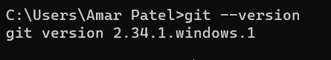

**Two types of version control system:**

1. **Centralized Version control system**

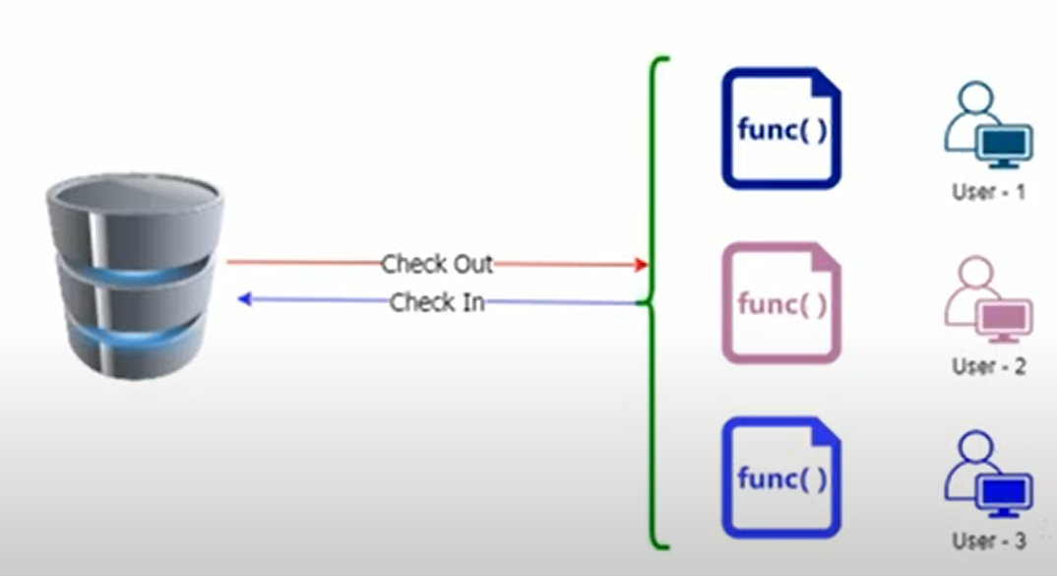

1. **Distributed Version control system (Git)**

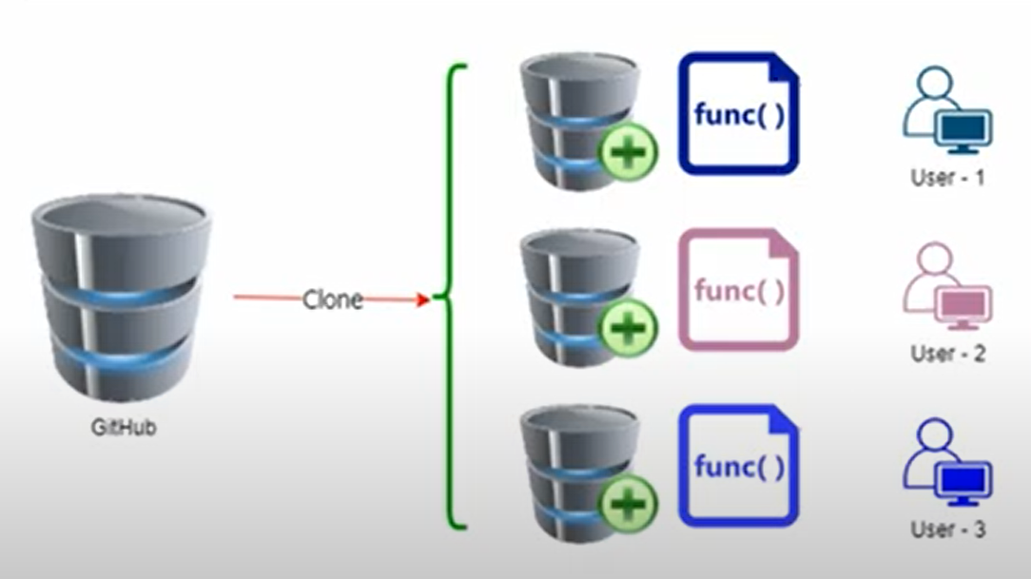

**Git Command Flow:**

Git init

Git add . or Git add index.html

Git clone HTTPSLINK

Git commit -m “message”

Git remote add origin URL OF GIT REPO

Git push -u origin master

**Git Branch:**

Git branch BRANCHNAME

Ex: git branch develop

Git checkout develop

Git push origin develop

**Git Merger :**

Git checkout master

Git merge develop